The Well-Architected Framework
The AWS Well-Architected Framework is designed to help you understand the advantages and disadvantages of the decisions you make when you build systems on AWS. AWS solutions architects have years of experience architecting solutions across a variety of business verticals and use cases, and they have helped design and review thousands of customer architectures on AWS. Based on their experience, solutions architects identified best practices and core strategies for architecting systems in the cloud. The Well-Architected Framework was built from these best practices and core strategies.
The Well-Architected Framework is intended for people in technology roles, such as chief technology officers (CTOs), architects, developers, and operations team members. It describes AWS best practices and strategies that you can use when you design and operate cloud workloads, and it also provides links to further implementation details and architectural patterns.
Using the Well-Architected Framework can help you learn architectural best practices for designing and operating secure, reliable, efficient, cost-effective, and sustainable workloads in the AWS Cloud. The Well-Architected Framework documents a set of foundational questions that help you understand if a specific architecture aligns well with cloud best practices. The framework provides a consistent approach to evaluating systems against the qualities you might expect from modern cloud-based systems, and the remediation that would be required to achieve those qualities.
You can thus use the Well-Architected Framework to consistently measure your architectures against AWS best practices and identify areas for improvement. The process for reviewing an architecture is a constructive conversation about architectural decisions, and it isn’t an audit mechanism. We believe that having well-architected systems increases the likelihood of business success. And as AWS continues to evolve, and as we continue to learn more from working with customers, we will continue to refine the definition of well-architected.
Pillars
Pillar Name | Pillar description
Operational Excellence | The ability to support development and run workloads effectively, gain insight into their operations, and to continuously improve supporting processes and procedures to deliver business value.
Security | The ability to take advantage of cloud technologies to protect data, systems, and assets in a way that can improve your security posture.
Reliability | The ability of a workload to perform its intended function correctly and consistently when it’s expected to, including the ability to operate and test the workload through its total lifecycle.
Performance Efficiency | The ability to use computing resources efficiently to meet system requirements, and to maintain that efficiency as demand changes and technologies evolve.
Cost Optimization | The ability to run systems to deliver business value at the lowest price point.
Sustainability | The ability to continually improve sustainability impacts by maximizing the benefits from provisioned resources and minimizing the total amount of required resources, with the goal of reducing energy consumption and increasing efficiency across all workload components.
General design principles
The Well-Architected Framework identifies a set of general design principles to facilitate good design in the cloud, which include the following:
- Stop guessing your capacity needs: If you overestimate or underestimate capacity when you deploy a workload, you might need to deal with expensive idle resources or the performance implications of limited capacity. Cloud computing can reduce these types of problems. With the cloud, you can use as much or as little capacity as you need, and you can also scale up and down automatically.
- Test systems at production scale: In the cloud, you can create a production-scale test environment on demand, complete your testing, and then decommission the resources. Because you only pay for the test environment when it's running, you can simulate your live environment for a fraction of the cost of testing on premises.
- Automate with architectural experimentation in mind: By using automation, you can create and replicate your workloads at low cost and minimize the expense of manual effort. You can track changes to your automation, audit the impact, and revert to previous parameters when necessary.
- Consider evolutionary architectures: In a traditional environment, architectural decisions are often implemented as static, one-time events, with a few major versions of a system during its lifetime. As a business and its context continue to evolve, these initial decisions might hinder the system's ability to deliver changing business requirements. In the cloud, the ability to automate and test on demand lowers the risk of impact from design changes. Thus, systems can evolve over time so that businesses can take advantage of innovations as a standard practice.
- Drive architectures using data: In the cloud, you can collect data on how your architectural choices affect the behavior of your workload. You can use this data to make fact-based decisions on how to improve your workload. Your cloud infrastructure is code, so you can use the data to inform your architectural choices and improvements over time.
- Improve through game days: You can test how your architecture and processes perform by regularly scheduling game days to simulate events in production. Running game days can help you understand where you can make improvements, and they can also help develop your organization’s experience in dealing with events.
For more information, see the AWS Well-Architected homepage.

Operational Excellence, Reliability, and Disaster Recovery
Operational excellence
The Operational Excellence pillar of the AWS Well-Architected Framework provides a structured approach to optimizing operations within your AWS environment. By following the best practices in this pillar, you can continually move your workload in the direction of being efficient, resilient, and improving over time. Operational excellence isn’t a destination. Instead, it’s an ongoing journey—and to thrive in the cloud, it's crucial to maintain a culture of innovation and learning within your organization.
The Operational Excellence pillar includes the ability to support development and run workloads effectively, to gain insight into their operations, and to continuously improve supporting processes and procedures to deliver business value.
Design principles
Operational excellence in the cloud includes the following five design principles:
- Perform operations as code: In the cloud, you can apply the same engineering discipline that you use for application code to your entire environment. You can define your entire workload (applications, infrastructure) as code and update it with code. You can implement your operations procedures as code and automate their run process by initiating them in response to events. By performing operations as code, you can reduce human error and achieve consistent responses to events.
- Make frequent, small, reversible changes: You can design workloads so that components can be updated regularly. Make changes in small increments that can be reversed if they fail (without affecting customers, when possible).
- Refine operations procedures frequently: As you use operations procedures, look for opportunities to improve them. As you evolve your workload, evolve your procedures appropriately. Set up regular game days to review and validate that all procedures are effective, and that teams are familiar with them.
- Anticipate failure: You can perform premortem exercises to identify potential sources of failure so that they can be removed or mitigated. Test your failure scenarios and validate your understanding of their impact. Test your response procedures to verify that they are effective, and that teams are familiar with their process. Set up regular game days to test workloads and team responses to simulated events.
- Learn from all operational failures: You can drive improvement through the lessons that are learned from all operational events and failures. Share what is learned across teams and through the entire organization.
Example questions for the Operational Excellence pillar
Each pillar of the Well-Architected Framework has questions that are associated with them. These questions are meant to help you understand if a specific architecture aligns well with cloud best practices. They are designed to help you think through all the different perspectives for your workload.
The following example questions are associated with the Operational Excellence pillar:
- OPS 1. How do you determine what your priorities are?
- OPS 4. How do you design your workload so that you can understand its state?
- OPS 10. How do you manage workload and operations events?
For information about how to answer these questions, see the Operational Excellence Pillar whitepaper.
For more general information about the Operational Excellence pillar, see Operational Excellence in the AWS Well-Architected Documentation.
Reliability
The Reliability pillar encompasses the ability of a workload to perform its intended function correctly and consistently when it’s expected to, including the ability to operate and test the workload through its total lifecycle.
Design principles
Reliability in the cloud includes the following five design principles:
- Automatically recover from failure: By monitoring a workload for key performance indicators (KPIs), you can automate a response when a threshold is breached. These KPIs should measure business value, not the technical aspects of the service’s operations. Monitoring makes it possible to automatically send notifications and track failures, and start automated recovery processes that work around or repair the failure. With more sophisticated automation, you can even anticipate and remediate failures before they occur.
- Test recovery procedures: In an on-premises environment, testing is often conducted to prove that the workload works in a particular scenario. Testing isn’t typically used to validate recovery strategies. In the cloud, you can test how your workload fails, and you can validate your recovery procedures. You can use automation to simulate different failures or to re-create scenarios that led to previous failures. Use this approach to expose failure pathways that you can test and fix before a real failure scenario occurs, thus reducing risk.
- Scale horizontally to increase aggregate workload availability: You can replace one large resource with multiple small resources to reduce the impact of a single failure on the overall workload. Distribute requests across multiple, smaller resources to verify that they don’t share a common point of failure.
- Stop guessing capacity: A common cause of failure in on-premises workloads is resource saturation, which occurs when the demands placed on a workload exceed the capacity of that workload. (This situation is often the objective of distributed denial of service [DDoS] attacks.) In the cloud, you can monitor demand and workload utilization, and automate the addition or removal of resources to satisfy demand without overprovisioning or underprovisioning. Service quotas still apply, but some quotas can be controlled, and others can be managed.
- Manage change in automation: Infrastructure changes should be made by using automation. The changes that must be managed include changes to the automation, which then can be tracked and reviewed.
Example questions for the Reliability pillar
The following example questions are associated with the Reliability pillar:
- REL 7. How do you design your workload to adapt to changes in demand?
- REL 9. How do you back up data?
- REL 10. How do you use fault isolation to protect your workload?
For more information about how to answer these questions, see the Reliability Pillar whitepaper.
For more general information about the Reliability pillar, see Reliability in the AWS Well-Architected Framework Documentation.
Disaster recovery
You can broadly categorize the disaster recovery (DR) strategies that are available in AWS into four approaches. These approaches range from the low cost and low complexity of making backups to more complex strategies using multiple active Regions. When you create your DR plan, consider the tradeoffs between using different strategies, and also consider the complexity and cost of different DR plans.
You also should be aware that DR plans are not one-size-fits-all plans. You can choose different DR methods for different workloads. Mission-critical systems might use an active-active or active-passive setup. However, less critical workloads might use the backup-and-restore option. A single correct DR plan for all workloads doesn’t exist.
Active-passive strategies use an active site (such as an AWS Region) to host the workload and serve traffic. The passive site (such as a different AWS Region) is used for recovery. The passive site doesn’t actively serve traffic until a failover event occurs.
DR strategies aren’t something that you set up one time and then forget about. You should test your setup regularly. It’s critical to regularly assess and test your DR strategy so that you can be confident invoking it, if it becomes necessary.
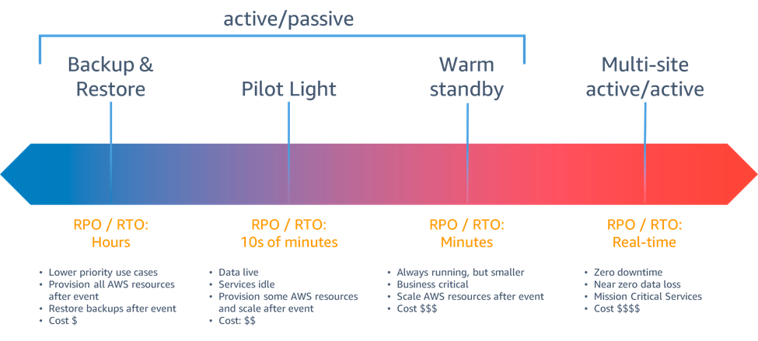
For more information about disaster recovery, including diagrams and examples, see Disaster recovery options on AWS.

Cybersecurity
What is cybersecurity?
Cybersecurity is the practice of safeguarding computers, networks, software applications, critical systems, and data from potential digital threats. Organizations are responsible for securing data to maintain customer trust and meet regulatory compliance. They use cybersecurity measures and tools to protect sensitive data from unauthorized access, and to prevent disruptions in business operations because of unwanted network activity. Organizations implement cybersecurity by streamlining digital defense amongst people, processes, and technologies.
Why is cybersecurity important?
Businesses in various sectors—such as energy, transportation, retail, and manufacturing—use digital systems and high-speed connectivity to provide efficient customer service and run cost-effective business operations. Just like they secure their physical assets, organizations must also secure digital assets and protect their systems from unintended access. An intentional event of breaching and gaining unauthorized access to a computer system, network, or connected facilities is called a cyber attack. A successful cyber attack results in the exposure, theft, deletion, or alteration of confidential data.
Cybersecurity measures defend against cyber attacks and provide the following benefits.
Prevent or reduce the cost of breaches
Organizations that implement cybersecurity strategies can minimize the consequences of cyber attacks that might impact business reputation, financial standings, business operations, and customer trust. For example, companies activate disaster recovery (DR) plans to contain possible intrusions and minimize disruption to business operations.
Maintain regulatory compliance
Businesses in specific industries and regions must comply with regulatory requirements to protect sensitive data against possible cyber risks. For example, companies that operate in Europe must comply with the General Data Protection Regulation (GDPR), which expects organizations to take appropriate cybersecurity measures to ensure data privacy.
Mitigate evolving cyber threats
Cyber attacks evolve alongside the changes in technologies. Criminals use new tools and devise new strategies for unauthorized system access. Organizations should employ and upgrade their cybersecurity measures to keep up with these new and evolving digital-attack technologies and tools.
What types of attacks does cybersecurity defend against?
Cybersecurity professionals strive to contain and mitigate existing and new threats that infiltrate computer systems in different ways. The following examples describe some common cybersecurity threats.
Malware
Malware stands for malicious software. It includes a range of software programs that are built to allow third parties to gain unauthorized access to sensitive information, or to interrupt the normal workings of a critical infrastructure. Common examples of malware include Trojans, spyware, and viruses.
Ransomware
Ransomware refers to a business model and a wide range of associated technologies that bad actors use to extort money from entities. Whether you’re getting started on AWS or already building cloud infrastructure, you can use various AWS and third-party resources that are dedicated to helping you protect your critical systems and sensitive data against ransomware.
Man-in-the-middle attack
A man-in-the-middle attack involves an outside party that attempts to get unauthorized access through a network during a data exchange. These types of attacks increase the security risks of sensitive information, such as financial data.
Phishing
Phishing is a cyber threat that uses social engineering techniques to trick users into revealing personally identifiable information (PII). An example of phishing is when cyber attackers send emails that users interact with to enter credit-card data on a fake payment webpage. Phishing attacks can also result in users downloading malicious attachments, which then install malware on company devices.
DDoS
A distributed denial of service attack (DDoS) is a coordinated effort to overwhelm a server by sending a high volume of fake requests. DDoS events prevent normal users from connecting to or accessing the targeted server.
Insider threat
An insider threat is a security risk that’s introduced by personnel with bad intentions within an organization. The personnel possess high-level access to the computer systems, and have the potential to destabilize the infrastructure’s security from within the organization itself.
OWASP Top Ten
The OWASP Top 10 is a standard awareness document for developers and web application security. It represents a broad consensus about the most critical security risks to web applications.
To learn about the latest top security threats, see OWASP Top Ten.
How does cybersecurity work?
Organizations implement cybersecurity strategies by engaging cybersecurity specialists. These specialists assess the security risks of existing computing systems, networks, data storage, applications, and other connected devices. Then, the cybersecurity specialists create a comprehensive cybersecurity framework and implement protective measures in the organization.
A successful cybersecurity program involves educating employees on security best practices and using automated cyber defense technologies for existing IT infrastructure. These elements are designed to work together to create multiple layers of protection against potential threats on all data access points.
What are the different types of cybersecurity?
Cybersecurity comprises various strategies that focus on different areas. The different types of cybersecurity can identify risk; protect identities, infrastructure, and data; detect anomalies and events; respond to and analyze root causes; and help with recovery after an event.
A robust cybersecurity approach within an organization addresses the following concerns.
Critical infrastructure cybersecurity
Critical infrastructure cybersecurity refers to cybersecurity protection that focuses on digital systems that are important to society. These critical infrastructure systems include digital systems in energy, communication, and transportation. Organizations in these areas require a systematic approach to cybersecurity because any interruption or data loss can destabilize society itself.
Network security
Network security is cybersecurity protection for computers and devices that are connected to a network. IT teams use network security technologies (such as firewalls and network access control) to regulate user access and manage permissions for specific digital assets.
Cloud security
Cloud security describes the measures that an organization takes to protect data and applications that run in the cloud. Cloud security is important to strengthening customer trust. It can help the organization ensure fault-tolerant operations and comply with data privacy regulations in a scalable environment. A robust cloud security strategy involves shared responsibility between the cloud vendor and the organization.
IoT security
The term Internet of Things (IoT) refers to electronic devices that operate remotely on the internet. For example, a smart alarm that sends periodic updates to your smartphone is considered to be an IoT device. IoT devices introduce an additional layer of security risk because they are constantly connected and might also have hidden software bugs. Thus, an organization must introduce security policies on the network infrastructure to assess and mitigate the potential risks of different IoT devices.
Data security
Data security protects data in transit and at rest with a robust storage system and secure data transfer. Developers use protective measures (such as encryption and isolated backups for operational resilience against possible data breaches. In some cases, developers use AWS Nitro System for storage confidentiality and restricting operator access.
Application security
Application security is a coordinated effort to strengthen an application's protection against unauthorized manipulation during the design, development, and testing stages. Software programmers write secure code to help prevent bugs that can increase security risks.
Endpoint security
Endpoint security addresses security risks that occur when users access an organization's network remotely. Endpoint security protection scans files from individual devices, and is designed to mitigate threats upon detection.
Disaster recovery and business continuity planning
Disaster recovery (DR) and business continuity planning describe contingency plans that allow an organization to respond promptly to cybersecurity incidents, while also allowing the organization to continue operating with little or no disruptions. These plans implement data recovery policies to respond positively to data losses.
End-user education
People within an organization play a crucial role in helping to ensure the success of cybersecurity strategies. Education is key so that employees are trained to follow good security best practices, such as deleting suspicious emails and not plugging in unknown USB devices.
What are modern cybersecurity technologies?
The following modern cybersecurity principles and technologies help organizations secure their data.
Zero trust
Zero trust is a cybersecurity principle that assumes that no applications or users are trusted by default, even if they are hosted within the organization. Instead, the zero-trust model assumes that access control is based on the principle of least privilege, which requires both strict authentication from the relevant authorities and continuous application monitoring. AWS uses zero-trust principles to authenticate and validate each individual API request.
Behavioral analytics
Behavioral analytics monitor data transmission from devices and networks to detect suspicious activities and abnormal patterns. For example, an IT security team is alerted when a sudden spike in data transmission occurs, or when the system detects many downloads of suspicious files to specific devices.
Intrusion detection systems
Organizations use intrusion detection systems to identify and quickly respond to a cyber attack. Modern security solutions use machine learning and data analytics to uncover dormant threats in the organization's computing infrastructure. The intrusion defense mechanism can also pick up a data trail if an incident occurs. The data trail can then help the security team discover the source of the incident.
Cloud encryption
Cloud encryption scrambles data before it’s stored in cloud databases, which helps prevent unauthorized parties from abusing the data in possible breaches. Organizations can use AWS Key Management Service (AWS KMS) to control data encryption in AWS workloads.
How does AWS help with cybersecurity?
As an AWS customer, you can benefit from using AWS data centers and a network architecture that’s designed to protect your information, identities, applications, and devices. With AWS, you can improve your ability to meet core security and compliance requirements, such as data locality, protection, and confidentiality. You can also use AWS and third-party offerings to help automate manual security tasks, which means that you can have more time to focus on scaling and innovating your business.
AWS cybersecurity services can help you do the following:
- Protect your data, accounts, and workloads from unauthorized access.
- Manage identities, resources, and permissions at scale.
- Enforce fine-grained security policy at network control points across your organization.
- Continuously monitor the network activity and account behavior within your cloud environment.
- Gain a comprehensive view of your compliance status by using automated compliance checks.
To learn more about cybersecurity, see What is Cybersecurity?

The Security Pillar
The security pillar describes how to take advantage of cloud technologies to protect data, systems, and assets in a way that can improve your security posture. This paper provides in-depth, best-practice guidance for architecting secure workloads on AWS.
Design principles
In the cloud, you can help strengthen your workload security by following these principles:
- Implement a strong identity foundation: Implement the principle of least privilege and enforce the separation of duties with appropriate authorization for each interaction with your AWS resources. Centralize identity management, and aim to eliminate reliance on long-term static credentials.
- Maintain traceability: Monitor, alert, and audit actions and changes to your environment in real time. Integrate the collection of logs and metrics with systems that are designed to automatically investigate and take action.
- Apply security at all layers: Apply a defense-in-depth approach by using multiple security controls. Apply security to all layers, such as the edge of the network; virtual private clouds (VPCs); load balancing; each instance and compute service, operating system, and application; and all code.
- Automate security best practices: Automated software-based security mechanisms can help you improve your ability to securely scale more rapidly and cost effectively. Create secure architectures, including implementing controls that are defined and managed as code in version-controlled templates.
- Protect data in transit and at rest: Classify your data into sensitivity levels and use mechanisms—such as encryption, tokenization, and access control—where appropriate.
- Keep people away from data: Use mechanisms and tools to reduce or eliminate the need for direct access to data, or the manual processing of data. These strategies reduce the risk of mishandling, modification, or human error when sensitive data must be handled.
- Prepare for security events: Prepare for an incident by aligning incident management, investigation policy, and investigation processes to your organizational requirements. Run incident response simulations and use tools with automation to help increase how quickly you can detect, investigate, and recover.
Example questions for the Security pillar
The following questions apply to the Security pillar of the Well-Architected Framework:
- SEC 2. How do you manage identities for people and machines?
- SEC 3. How do you manage permissions for people and machines?
- SEC 4. How do you detect and investigate security events?
- SEC 5. How do you protect your network resources?
NAT
You can use a Network Address Translation (NAT) device to allow resources in private subnets to connect to the internet, other VPCs, or on-premises networks. These instances can communicate with services outside the VPC, but they can’t receive unsolicited connection requests.
The NAT device replaces the source IPv4 address of the instances with the address of the NAT device. When the NAT device sends response traffic to the instances, it translates the addresses back to the original source IPv4 addresses.
NAT gateways
You can use a managed NAT device offered by AWS that’s called a NAT gateway. You can also create your own NAT device on an Amazon Elastic Compute Cloud (Amazon EC2) instance, which is then called a NAT instance. We recommend that you use NAT gateways because they provide better availability and bandwidth, and they also require less effort on your part to administer.
A NAT gateway is a NAT service that can connect instances in a private subnet to services that are outside your VPC, and that can’t initiate a connection with the private subnet instances.
When you create a NAT gateway, you specify one of the following connectivity types:
- Public: (Default) Instances in private subnets can connect to the internet through a public NAT gateway, but they can’t receive unsolicited inbound connections from the internet. You create a public NAT gateway in a public subnet, and you must associate an Elastic IP address with the NAT gateway when you create it. You can route traffic from the NAT gateway to the internet gateway for the VPC. Alternatively, you can use a public NAT gateway to connect to other VPCs or your on-premises network. In this case, you can route traffic from the NAT gateway through a transit gateway or a virtual private gateway.
- Private: Instances in private subnets can use a private NAT gateway to connect to other VPCs or your on-premises network. You can route traffic from the NAT gateway through a transit gateway or a virtual private gateway. You can’t associate an Elastic IP address with a private NAT gateway. You can attach an internet gateway to a VPC with a private NAT gateway. However, if you route traffic from the private NAT gateway to the internet gateway, the internet gateway drops the traffic.
Both private and public NAT gateways map the source private IPv4 address of the instances to the private IPv4 address of the NAT gateway. However, in the case of a public NAT gateway, the internet gateway then maps the private IPv4 address of the public NAT gateway to the Elastic IP address that’s associated with the NAT gateway. When the NAT gateway sends response traffic to the instances, it translates the address back to the original source IP address, regardless of whether the NAT gateway is public or private.
Each NAT gateway is created in a specific Availability Zone, and is implemented with redundancy in that zone.
To learn more about NAT gateways, see NAT Gateways.
Amazon GuardDuty
Amazon GuardDuty is a threat-detection service that near-continuously monitors your AWS accounts and workloads for malicious activity, and delivers detailed security findings for visibility and remediation.
Amazon GuardDuty analyzes and processes data from foundational data sources to detect anomalies involving AWS Identity and Access Management (IAM) access keys and Amazon Elastic Compute Cloud (Amazon EC2). You can also activate GuardDuty protection plans to analyze additional data from other AWS services in your AWS environment to protect workloads that use Amazon Simple Storage Service (Amazon S3), Amazon Elastic Kubernetes Service (Amazon EKS), Amazon Relational Database Service (Amazon RDS), and AWS Lambda.
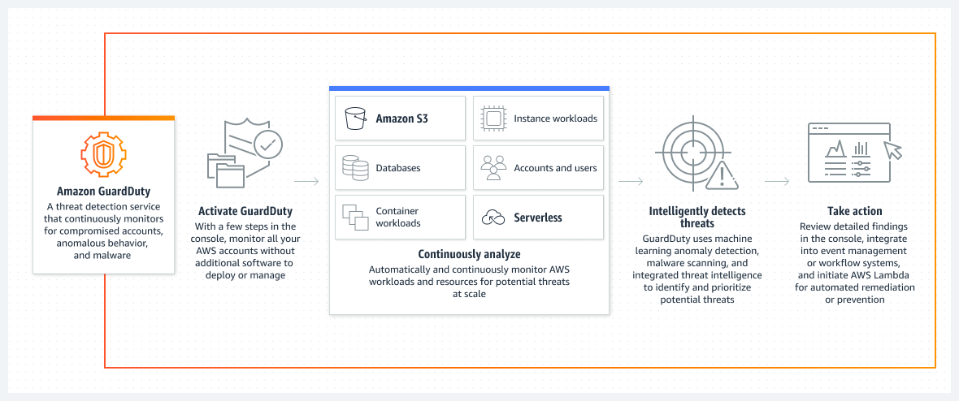
To learn more about Amazon GuardDuty, see What Is Amazon GuardDuty?

Performance Efficiency and Cost Optimization
Performance Efficiency
The Performance Efficiency pillar of the AWS Well-Architected Framework is designed to help you build architectures on AWS that efficiently deliver sustained performance over time. It’s also designed to lessen the challenge often seen in traditional, on-premises environments that want to achieve high and lasting performance. Implementing the guidance from the Performance Efficiency pillar involves taking a data-driven approach to designing and building your architectures. It also involves gathering data on all aspects of the architecture, from its high-level design to the selection and configuration of resource types.
It’s also important to review your choices on a regular basis so you can take advantage of the continually evolving AWS Cloud. Additionally, you can use monitoring to be notified of any deviation from expected performance. Monitoring also gives you an ongoing way to continuously gather and evaluate data about the level of functionality you’re achieving with your systems, applications, and architectures.
The guidance and best practices of the Performance Efficiency pillar are spread across five key areas of focus that serve as guiding principles for building performance-efficient cloud solutions on AWS. The focus areas are the following:
- Architecture selection: The optimal solution for a particular workload varies, and solutions often combine multiple approaches. You should focus on how to select efficient, high-performing cloud resources and architecture patterns.
- Compute and hardware: The guidance in this focus is centered around how to identify and optimize compute options for performance efficiency in the cloud.
- Data management: This focus area prioritizes guidance and best practices for optimizing data storage, movement and access patterns, and the performance efficiency of data stores.
- Networking and content delivery: The basis of this focal point is to optimize the design, configuration, and efficient operation of network and content delivery solutions in the AWS Cloud.
- Process and culture: This focus area provides principles and practices that you can adopt to help efficient, high-performing workloads run better. It also offers best practices to help adopt a culture that fosters the performance efficiency of cloud workloads.
Design principles
The following design principles can help you achieve and maintain efficient workloads in the cloud:
- Democratize advanced technologies: Make advanced technology implementation easier for your team by delegating complex tasks to your cloud vendor. Instead of asking your IT team to learn about hosting and running a new technology, consider consuming the technology as a service. For example, NoSQL databases, media transcoding, and machine learning are all technologies that require specialized expertise. In the cloud, these technologies become services that your team can consume, which means that your team can focus on product development instead of provisioning and managing resources.
- Go global in minutes: Because you can deploy your workload in multiple AWS Regions around the world, you can provide lower latency and a better experience for your customers at a reduced cost.
- Use serverless architectures: With serverless architectures, you no longer need to run and maintain physical servers for traditional compute activities. For example, serverless storage services can act as static websites (thus removing the need for web servers) and event services can host code. Using serverless architectures removes the operational burden of managing physical servers. Additionally, they can also lower transactional costs because managed services operate at cloud scale.
- Experiment more often: With virtual and automatable resources, you can quickly carry out comparative testing by using different types of instances, storage, or configurations.
- Consider mechanical sympathy: Use the technology approach that aligns best with your goals. For example, consider data access patterns when you select a database or storage for your workload.
Example questions for the Performance Efficiency pillar
Each pillar of the Well-Architected Framework has questions that are associated with them. These questions are meant to help you understand if a specific architecture aligns well with cloud best practices. They are designed to help you think through all the different perspectives for your workload.
The following example questions are associated with the Performance Efficiency pillar:
- PERF 1. How do you select the appropriate cloud resources and architecture patterns for your workload?
- PERF 3. How do you store, manage, and access data in your workload?
- PERF 5. What process do you use to support more performance efficiency for your workload?
For additional information about the Performance Efficiency pillar, see Performance Efficiency in the AWS Well-Architected Documentation.
Cost Optimization
Design principles
A cost-optimized workload fully uses all resources, achieves an outcome at the lowest possible price point, and meets your functional requirements. The Cost Optimization pillar provides you with guidance for building capability within your organization, designing your workload, selecting your services, configuring and operating the services, and applying cost-optimization techniques.
Cost optimization can be challenging in traditional on-premises solutions because you must predict future capacity and business needs while you also navigate complex procurement processes. Adopting the practices described in the Cost Optimization pillar can help your organization achieve various goals, such as building awareness of expenditure and usage, evaluating and using cost-effective resources, continually optimizing over time, and more.
Consider the following design principles for cost optimization:
- Implement cloud financial management: To achieve financial success and accelerate business value realization in the cloud, you must invest in cloud financial management. Your organization must dedicate the necessary time and resources for building capability in this domain of technology and usage management. Similar to your Security or Operations capability, you need to build capability—through knowledge building, programs, resources, and processes—to help your organization become cost efficient.
- Adopt a consumption model: In a consumption model, you pay only for the computing resources you consume, and you also increase or decrease usage depending on business requirements. For example, development and test environments are typically only used for 8 hours a day during the work week. You can stop these resources when they’re not in use for a potential cost savings of 75 percent (that is, by paying for 40 hours of usage, compared to 168 hours).
- Measure overall efficiency: Measure the business output of the workload and also measure the costs associated with delivery. Use this data to understand the gains you can make from increasing output, increasing functionality, and reducing cost.
- Stop spending money on undifferentiated heavy lifting: AWS does the heavy lifting of data center operations, such as racking, stacking, and powering servers. AWS also removes the operational burden of managing operating systems and applications by offering managed services. By using AWS, you can focus on your customers and business projects instead of spending time on provisioning and managing IT infrastructure.
- Analyze and attribute expenditure: The cloud makes it easier to accurately identify the cost and usage of workloads, which can then result in the transparent attribution of IT costs to revenue streams and individual workload owners. This data can help your organization measure return on investment (ROI). Workload owners can also use the data to optimize their resources and reduce costs.
Example questions for the Cost Optimization pillar
The following example questions are associated with the Cost Optimization pillar:
- COST 2. How do you govern usage?
- COST 5. How do you evaluate cost when you select services?
- COST 11. How do you evaluate the cost of effort?
For more information about the Cost Optimization pillar, see Cost Optimization in the AWS Well-Architected Framework Documentation.

Question 1
Cloud architects use the AWS Well-Architected Framework to build secure, high-performing, resilient, and efficient infrastructure for a variety of applications and workloads. Now that you’ve learned more about each Well-Architected pillar, which one do you think is the most important, and why?

That’s a great reflective question. Each pillar of the AWS Well-Architected Framework is essential, but if I had to argue for the most important, I’d choose the Security pillar. Here’s why:
- 🔐 Foundation of trust: Without strong security, even the most reliable or cost-efficient system can’t be trusted. Protecting identity, data, and workloads is the baseline for everything else.
- 🌍 Regulatory and compliance impact: Security directly ties into legal obligations, industry standards, and customer confidence. A breach can undo years of architectural excellence.
- 🛡️ Enabler of innovation: When security is baked in, architects can confidently experiment with performance, reliability, and cost optimization without worrying about exposing vulnerabilities.
- ⚖️ Interdependency: Other pillars (Reliability, Performance Efficiency, Cost Optimization, Sustainability) all depend on secure foundations. For example, scaling capacity or optimizing costs is meaningless if sensitive data is compromised.
That said, some architects argue Reliability is equally critical—because if your system isn’t resilient, security and performance don’t matter when it’s down. In practice, the “most important” pillar often depends on the workload: a healthcare app might prioritize security, while a streaming service might emphasize performance efficiency.

Sustainability and The Well Architected Tool
Sustainability
An increasing number of organizations are setting sustainability targets in response to changes in government regulations; competitive advantage; and customer, employee, and investor demand. CTOs, architects, developers, and operations team members are seeking ways that they can directly contribute to their organization's sustainability goals. You can use the Sustainability pillar's design principles—and the best practices supported by AWS services—to make informed decisions that balance security, cost, performance, reliability, and operational excellence with sustainability outcomes for your AWS Cloud workloads.
Every action you take to reduce resource usage and increase efficiency across your workloads reduces their environmental impact, and also contributes to your organization’s broader sustainability goals.
The shared responsibility model
- AWS is responsible for optimizing the sustainability of the cloud—that is, delivering efficient, shared infrastructure; practicing water stewardship; and sourcing renewable power.
- Customers are responsible for sustainability in the cloud—that is, optimizing workloads and resource utilization, and minimizing the total resources that your workloads require for deployment.
Environmental sustainability is a shared responsibility between customers and AWS.
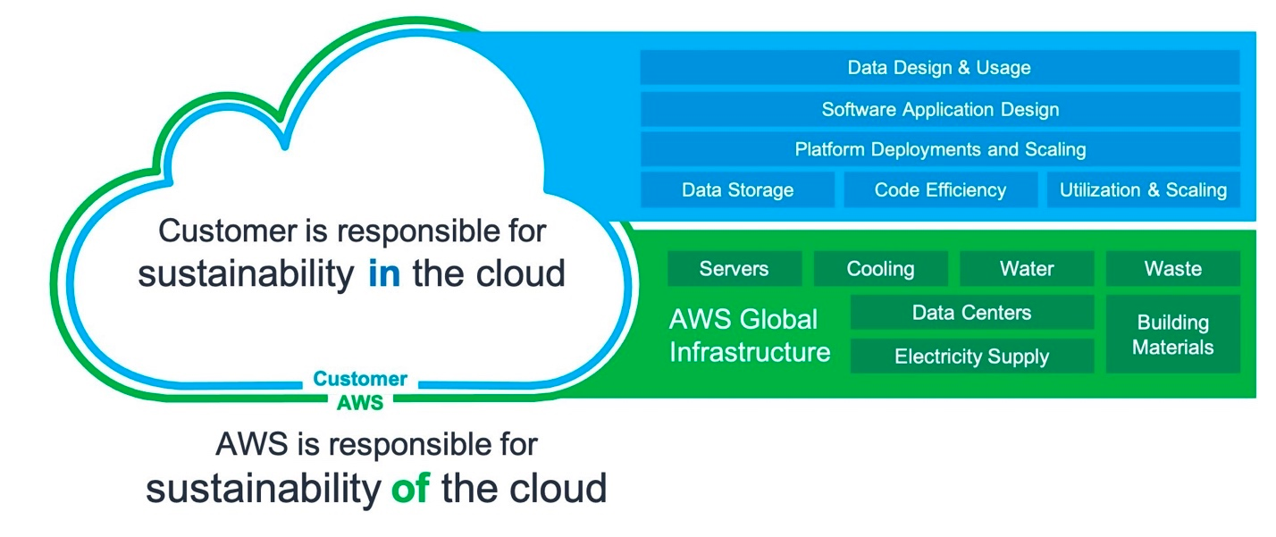
For additional information about the breakdown of responsibilities regarding the Sustainability pillar, see Sustainability of the Cloud and Sustainability in the Cloud in the AWS Documentation.
Design principles
To maximize sustainability and minimize impact, apply these design principles when you architect your cloud workloads:
- Understand your impact: Measure the impact of your cloud workload and model the future impact of your workload. Include all sources of impact, including impacts that result from customer use of your products, and impacts that result from eventually decommissioning and retiring your products. Compare the productive output with the total impact of your cloud workloads by reviewing the resources and emissions required per unit of work. Use this data to establish key performance indicators (KPIs), evaluate ways to improve productivity while reducing impact, and estimate the impact of proposed changes over time.
- Establish sustainability goals: For each cloud workload, establish long-term sustainability goals, such as reducing the compute and storage resources that each transaction requires. Model the return on investment (ROI) of sustainability improvements for existing workloads, and give owners the resources they need to invest in sustainability goals. Plan for growth, and architect your workloads so that the result of growth is a reduction in the intensity of impact as measured against an appropriate unit, such as per user or per transaction. These goals help you support the wider sustainability goals of your business or organization, identify regressions, and prioritize areas of potential improvement.
- Maximize utilization: Right-size workloads and implement efficient designs that both support high utilization and maximize the energy efficiency of the underlying hardware. For example, because of baseline power consumption per host, two hosts that run at 30 percent utilization are less efficient than one host that runs at 60 percent. At the same time, eliminate or minimize idle resources, processing, and storage to reduce the total energy required to power your workload.
- Anticipate and adopt new, more efficient hardware and software offerings: Support the upstream improvements that your partners and suppliers make to help you reduce the impact of your cloud workloads. Continually monitor and evaluate new, more efficient hardware and software offerings. Design for flexibility so that your organization can rapidly adopt new efficient technologies.
- Use managed services: Sharing services across a broad customer base helps maximize resource utilization, which reduces the amount of infrastructure needed to run cloud workloads. For example, customers can share the impact of common data center components (such as power and networking) by migrating workloads to the AWS Cloud. Customers can also share their impact by adopting managed services (such as AWS Fargate for serverless containers), where AWS both operates at scale and is responsible for operating the services efficiently. Using managed services can help minimize your impact by automatically moving infrequently accessed data to cold storage with Amazon Simple Storage Service (Amazon S3) Lifecycle configurations, or using Amazon Elastic Compute Cloud (Amazon EC2) Auto Scaling to adjust capacity to meet demand.
- Reduce the downstream impact of your cloud workloads: Reduce the amount of energy or resources required to use your services. Reduce or eliminate the need for customers to upgrade their devices to use your services. Test by using device farms to understand expected impact. Finally, test with customers to understand the actual impact of using your services.
Example questions for the Sustainability pillar
Each pillar of the Well-Architected Framework has questions that are associated with them. These questions are meant to help you understand if a specific architecture aligns well with cloud best practices, and are designed to help you think through all the different perspectives for your workload.
The following example questions are associated with the Sustainability pillar:
- SUS 2. How do you align cloud resources to your demand?
- SUS 4. How do you take advantage of data management policies and patterns to support your sustainability goals?
- SUS 5. How do you select and use cloud hardware and services in your architecture to support your sustainability goals?
For additional information about the Sustainability pillar, see Sustainability in the AWS Well-Architected Documentation.
The AWS Well-Architected Tool
The Well-Architected Framework provides a consistent approach for measuring architectures and provides guidance for implementing designs that scale with your needs over time.
The AWS Well-Architected Tool (AWS WA Tool) is a service in the cloud that provides a consistent process for documenting and measuring your architecture by using AWS best practices. These best practices were developed by AWS Solutions Architects based on their years of experience building solutions across a variety of businesses.
The AWS WA Tool helps you with the following tasks throughout the product lifecycle:
- Assisting with documenting the decisions that you make
- Providing recommendations for improving your workload based on best practices
- Guiding you in making your workloads more reliable, secure, efficient, and cost-effective
In addition to AWS best practices, you can use custom lenses to measure your workload using your own best practices. You can customize the questions in a custom lens to be specific to a particular technology, or to help you meet the governance needs within your organization. Custom lenses extend the guidance provided by the AWS lenses.
Integrations with AWS Trusted Advisor and AWS Service Catalog AppRegistry help you more easily discover the information that you need to answer Well-Architected review questions.
Steps for using the AWS WA Tool
Performing a review with the AWS WA Tool involves four steps:
- Define a workload.
- Document the workload state.
- Review the improvement plan.
- Make improvements and measure progress.
To gain a better understanding of what these steps involve, and to access a walkthrough that guides you through using the AWS WA Tool, see the AWS WA Tool tutorial page in the AWS Documentation.
For more information about getting started with the AWS WA Tool, see AWS Well-Architected Tool in the AWS Well-Architected Documentation.

